Dear Parents/ Carers
We hope you and your families are well and have been able to enjoy a good Easter break despite the current, unusual circumstances.
During our virtual staff Professional Development day on Tuesday 14 April and over the Easter break, we have been developing our use of the online learning system Google Classroom. As a Trust and a School we have decided to move to using this system to set all online learning. We believe Google Classroom offers an improved range of online learning information, is more effective in tracking students’ progress and provides better access for students and staff to communicate with each other through “chat” and “live” sessions.
From Monday 20 April, all work will be set on Google Classroom so your son/ daughter needs to be able to login to this system rather than SMHW to access the work set by their class teachers from this date. As mentioned, students can use the portal on this system to contact their teachers and Google Classroom also allows staff to set more differentiated tasks appropriate to individual students.
A guide follows which includes information on what to do if your son/ daughter is experiencing any difficulties when logging into the Google Classroom system by contacting, who can reset passwords etc. ccahillane@seckfordeducation.org.uk.
To support our community in effective learning, Tutors and the Pastoral team will be working with teaching staff to help monitor student engagement and liaise with parent/ carers as necessary.
We are working hard to respond to Government guidance and as we are adopting Google Classroom as a new system for all, feedback is always welcome. Our aim is try to make students’ learning at home the best it can be throughout this time.
Thank you for all your continued support, we appreciate this and the fantastic job parent/ carers are doing in facilitating the learning for our students at home.
Kind regards,
Mrs P Parker
Head of School
The school week

Across a school week, students at Key Stage 3 and 4 have been advised to complete 3 and 4 hours per day respectively; our suggested model of allocation of hours to subjects to provide an effective balance is shown below:

Subject | Key Stage 3 | Subject | Key Stage 4
English | 3 | English | 3
Maths | 3 | Maths | 3
Science | 2 | Science | 3
History | 1 | Option 1 | 2
Geography | 1 | Option 2 | 2
MFL/ Interventions | 1 | Option 3 | 2
Creatives | 2 | Option 4/ Study Support | 2
Beliefs & Values | 1
PE Activity | 2 | PE Activity | 2
Total | 16 hours | Total | 19 hours

Key Stage 3
 | Monday | Tuesday | Wednesday | Thursday | Friday
9-10am | English | Maths | Science | Beliefs & Values | English
Break
10.30-11.30 | MFL/Lexia | English | Science | Geography | Creative
Break
12-1pm | PE | Creative | Maths | History | Maths

Key Stage 4
 | Monday | Tuesday | Wednesday | Thursday | Friday
9-10am | English | English | Maths | History  Geography | History  Geography
Break
10.30-11.30 | MFL | Maths | Science | Science | Creative
Break
12-1pm | Maths | MFL | Science | English | Creative
Lunch
2-3pm | PE | Clash/catch up | PE | Clash/catch up | Clash/catch up

In addition to the daily availability of teaching staff through the Google Classroom learning platform, each week will be structured with 'live' access focus days as below. On these specified days, teaching staff within the named department(s) will be available across the school day of 9 am - 3.30 pm to respond to student queries.

Day | Subject
Monday | English/ MFL
Tuesday | Maths
Wednesday | Science
Thursday | Humanities: History/ Geography
Friday | Creatives/ PE

Google Classroom – A quick guide

- Search online for ‘Google Classroom’ or enter https://classroom.google.com
The below should appear (without Miss Moe’s details)
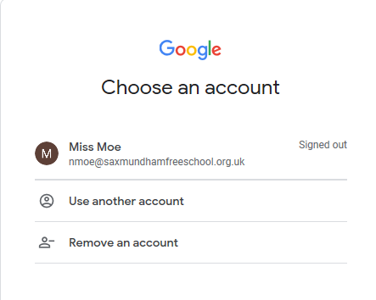
- Sign in using your Chromebook account details (____@ixworthfreeschool.org.uk– if you have forgotten them, email the below staff member who will reset your account and email back your new password. If you are at Ixworth, email Miss Cahillane on ccahillane@seckfordeducation.org.uk. Once you have signed in, press the + button in the top right of the screen then click ‘Join class’
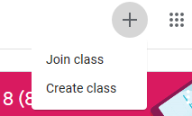

- Your class teachers will give you a class code to fill in, type it in here
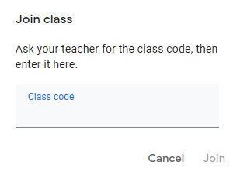
- Once you have successfully joined classes, your homepage for Google Classroom should have different classes in it
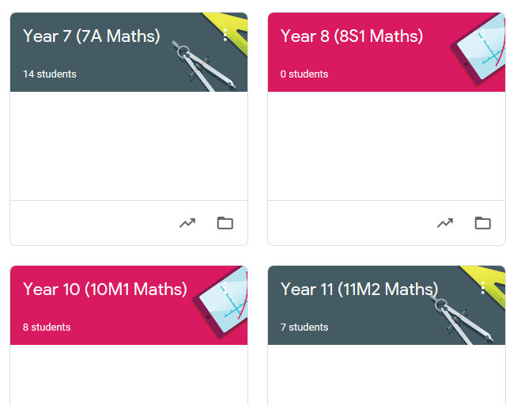

Trouble shooting
“I can’t get on to Google Classroom”
Double check your log in details – it should be your Chromebook log in _____@ixworthfreeschool.org.uk ,and your Chromebook password. If you still can’t sign in then email the staff member identified in the ‘how to’.
“The code doesn’t work”
The code is case sensitive, make sure you have copied it properly and haven’t copied and pasted instead (sometimes this copies over a space which confuses the computer). If you still can’t get on, email your class teacher who can add you manually instead.

Even though we are not working together at our school site, the ethos and 6Cs which we expect at SET Ixworth are still equally important in the online world. All interactions and contributions to virtual learning need to meet the same standards expected at school:
Community- Everyone is being impacted by the lockdown in different ways. We need to be supportive of each other, as very few of us know what difficulties others are facing. Any language, comments or contributions made online need to be respectful and appropriate. If you would not say it in person at school, do not say it online.
Challenge – Whilst you are learning at home, push yourself to improve as a learner and as an individual. What new skills can you learn? How can you improve yourself as a person? True improvement will come from doing more than just the minimum. Utilise your time well and let your Tutors know what you are doing to challenge yourself.
Commitment – Think of every piece of work that you are completing as helping your future self. Every effort you put in will make life for the future you a little better. Every piece of revision will improve your grades; every piece of gardening will improve your surroundings; every hour spent learning an instrument will develop your skill. Be committed to use the time you have and share your experiences.
Co-operation – This is a time when helping others is so important, and our co-operation is what makes SET Ixworth such a unique and successful community. How can you make the lives of others easier? How can you help your family and friends? Working with others and offering support to your peers who maybe struggling to complete a piece of work will improve your understanding

Confidence – “Amateurs practise until they get it right; professionals practise until they can’t get it wrong”. This quote is about being so experienced at something that you are confident that every time you do it you will succeed. Everything is hard until it is easy; life and learning both require effort from you to gain confidence. Push yourself to do the work that might be a challenge for you, use the resources available, your teachers and peers to tackle the problem in a different way – then share your successes.

Celebration – Search for the positives in all that you do when at home. Your teachers at SET Ixworth want you to achieve and exceed your highest ambitions, every success is a step towards doing so which you can look back on with pride. If you have completed something that has helped someone else, or that improves your knowledge or skills, we want to know. Take the opportunity and celebrate your efforts with us, as we are still going to be doing all we can to help you succeed.

Community
Strive to contribute kindly, positively and support those around you at all times when working on line.
Challenge
Whilst you are learning at home, push yourself to improve as a learner and as an individual.
Commitment
Be committed to use the time you have effectively and share your experiences.
Co-operation
This is a time when helping others is so important, our co-operation is what makes SET Ixworth such a unique and successful community. Work with others and support those around you.
Confidence
Everything is hard until it is easy; life and learning both require effort from you to gain confidence. Push yourself to do the work that might be a challenge for you.

Celebration

Search for the positives in all that you do when at home then celebrate your successes with us.

